Dear Parents,

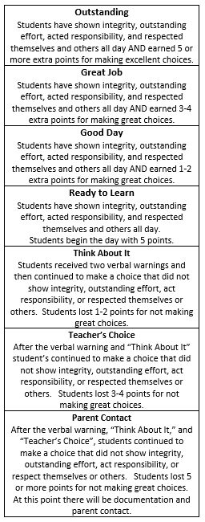 This year, Pleasant Garden will be implementing a new behavior system. To go along with our clip chart, behavior will also be documented electronically through an app called “Class Dojo.” Every day students will earn plus points (dings) for showing positive classroom behavior and minus points (dongs) for forgetting appropriate classroom behavior. This app will mimic what is seen on the clip chart and be an easy way to track and save student’s behavior (see example chart below). Parents will be linked into the app and will get reports each day about their child’s behavior. You may also opt to receive notifications throughout the day to see when your child receives and loses points. All teachers your child interacts with throughout the day may award or take away points. You will see which teacher does this in the notifications. Class dojo will also be used to share class pictures and as a messenger to communicate with parents.

You will be receiving an **access code** for your child. Please log onto to the app or website to create an account. I will receive an email once you have done so, and daily reports will begin for your child. If you have any questions about logging in or setting up an account, please let me know. This will be your source for daily updates.

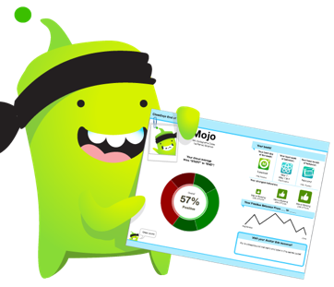Thank you in advance for all of your support. We are looking forward to all of us working together to help your child learn and grow this school year!

Thank you,

Mrs. Wright & Mrs. Cooke